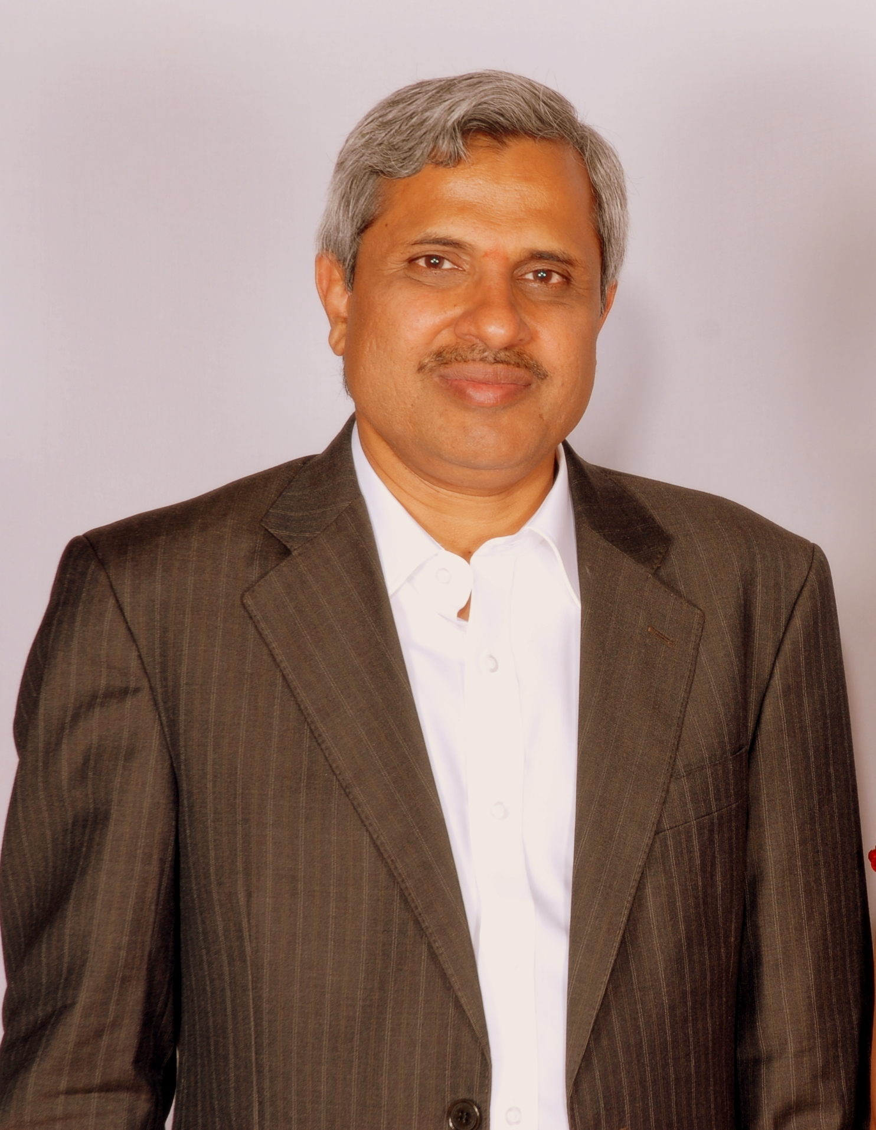
Professor Satchidananda Sogala. PH.D.,
Dr Satchidananda is the Founder and CEO of Srichid Technologies Private Limited ; Development Technologies & Research LLC USA ; srichid GLOBALMICROFINANCE FOUNDATION and srichid HEALTHCARE . He has more than 30 years of financial domain and technology solutioning experience. He most recently held national leadership positions with HP and IBM. He also worked with the Reserve Bank of India for more than 26 years also serving as the Regional Director at RBI – Orissa State. He has extensive financial domain expertise gained through three decades of experience. He has M.S. in Financial Markets (Illinois) and a PH.D in Economics with research performed on Financial Risk Management. He is also skilled in creating Risk Models for the Financial Services Industry. Professor Satchidananda Sogala was also the Founder & CEO of GLOBALRISKHUB and the originator of the innovative technology -based solution for the delivery of financial & other services delivery ,GANASEVA , which is being used by several MFIs and commercial banks in India for their operations.
Dr Satchidananda has over 30 years of experience in financial services and technologies; Handled large technology implementation projects; Conducted research and consulting in the area of risk intelligence and analytics in India and abroad; Has published over 20 papers in the area of risk modeling and risk technology solutioning ; Held the position of Professor & Research Director , CBIT, International Institute of Information Technology , Bangalore and lectured at Indian Institute of Management & Indian Institute of Technology and keynote speaker at several international Conferences , Symposiums & Workshops. Formerly, he has significant management and technology experience both in the Government and Private Sector , in his capacity as the Regional Director, Reserve Bank of India and later as Head of Risk Solutions and Research at HP India & IBM and Research Director at CBIT International Institute of Information Technology. He holds MS (ECON) from University of Illinois at Urbana-Champaign, USA, & Ph.D. ( Credit Risk Quantification), and various other certifications ,M.A., L.L.LB, CAIIB, CRB , B.A.ED, P.G.C.T.E.,O.D.E.,& ISO 9001 Lead Auditor , Information Systems Audit , SAS Programming & Data Mining , Oracle DBA, JDE One World & Microsoft Server Certifications. He is also the Regional Director, Professional Risk Managers International Association, and Bangalore.

